# Assignment C Tops Tech.

# Display This Information using printf

# 1. Your Name

# 2. Your Birth date

# 3. Your Age

# 4. Your Address

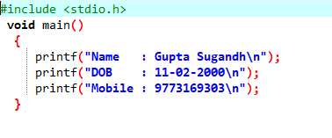

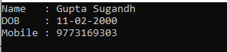

# Write a program to make Simple calculator (to make addition, subtraction,

# multiplication, division and modulo)

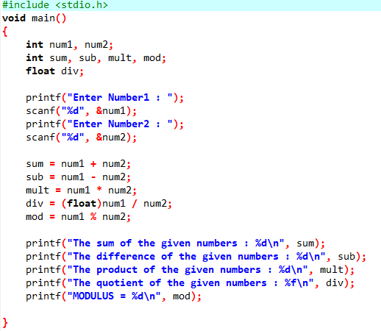

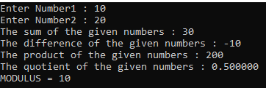

# WAP to find area of circle, rectangle and triangle

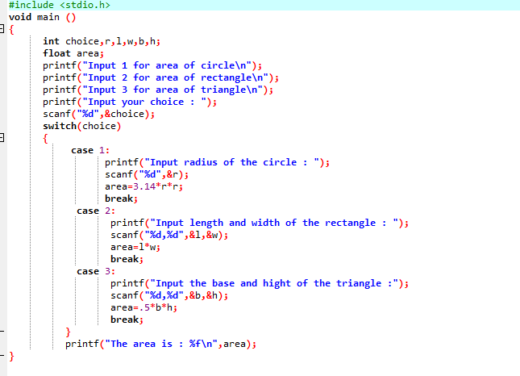

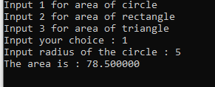

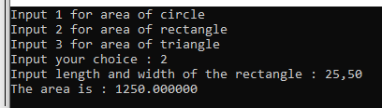

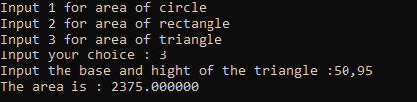

# WAP to find simple interest

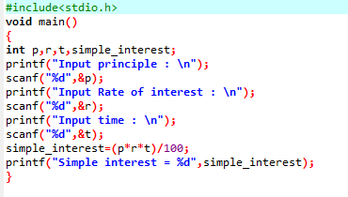

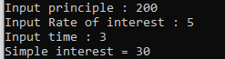

# WAP to check if the given year is a leap year or not.

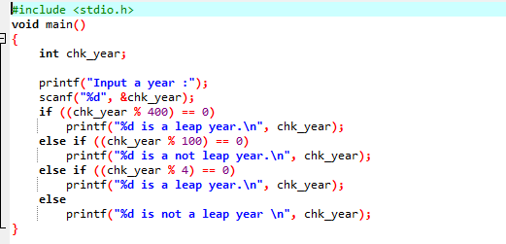



# WAP to convert years into days and days into years

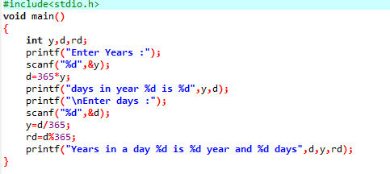

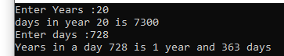

# MODULE: 3.2 (C Language Programing with C)

# WAP to swap two numbers without using third variable

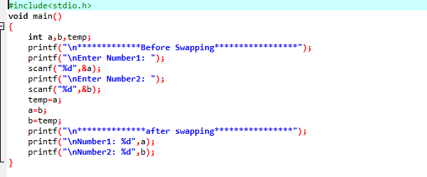

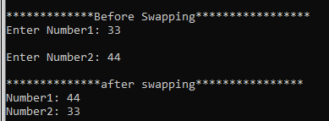

# WAP to find number is even or odd using ternary operator

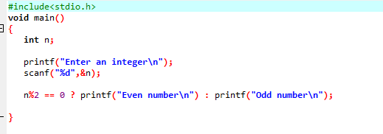



# WAP to show 1. Monday to Sunday using switch case

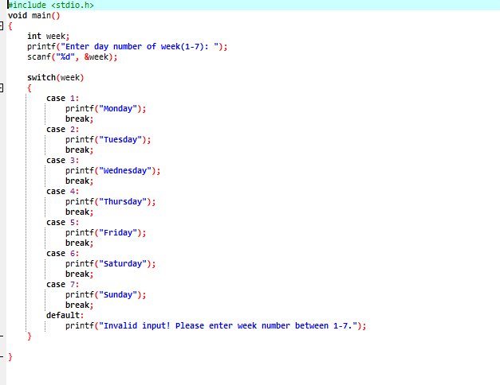



# 2. Vowel or Consonant using switch case

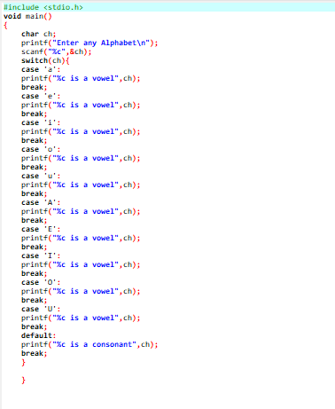



# Looping programs: 1. WAP to print 972 to 897 using for loop

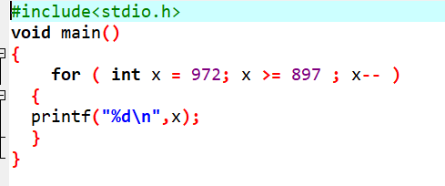



# 2. WAP to take 10 no. Input from user and find out …

# 3. How many Even numbers are there

# 4. How many odd numbers are there

# 5. Sum of even numbers

# 6. Sum of odd numbers

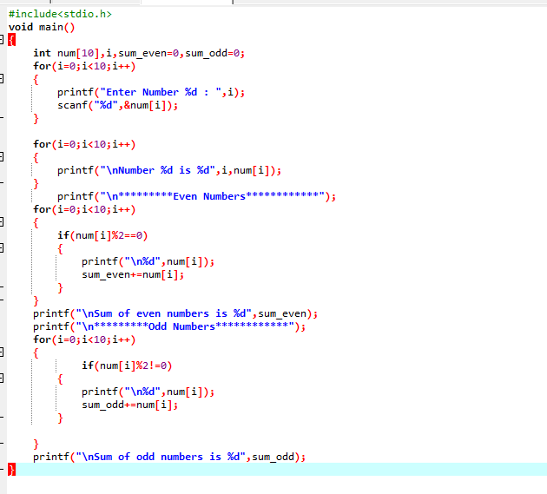

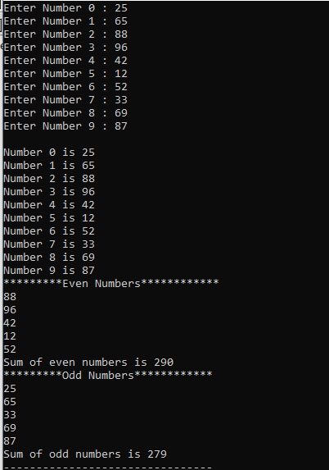

# WAP to print table up to given numbers

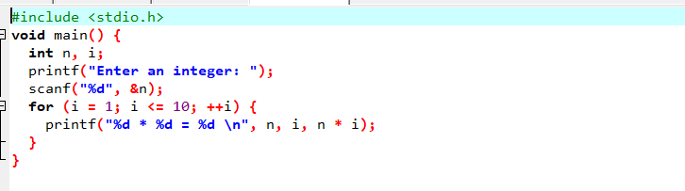

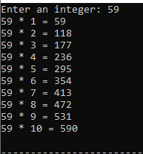

# WAP to print factorial of given number

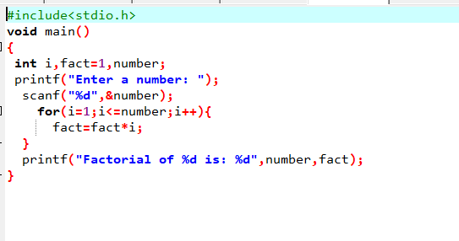



# WAP to print Fibonacci series up to given numbers

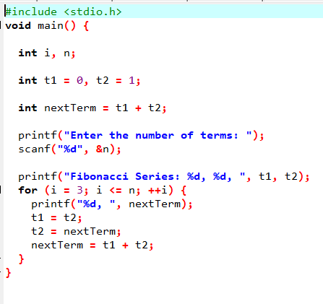



# WAP to print number in reverse order e.g.: number = 64728 ---> reverse = 82746

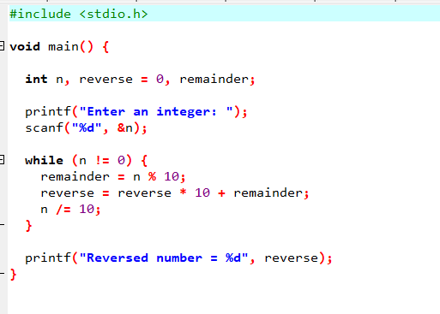



# Write a program to find out the max from given number (E.g., No: -1562 Max number is 6)

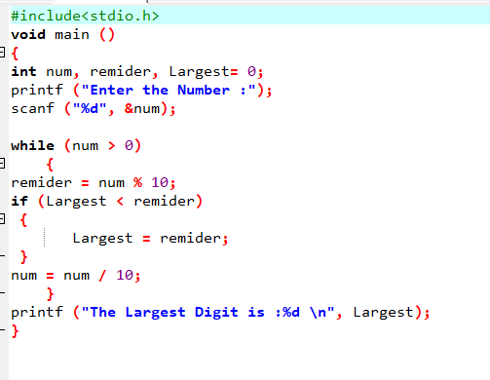



# Write a program make a summation of given number (E.g., 1523 Ans: -11)

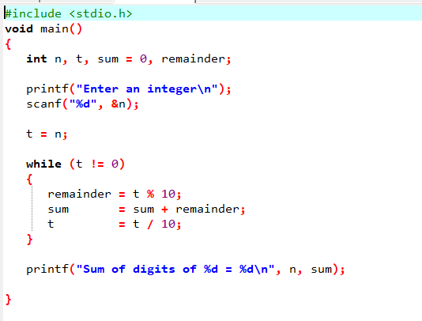

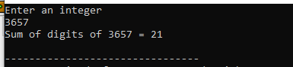

# Write a program you have to make a summation of first and last Digit. (E.g., 1234 Ans: -5)

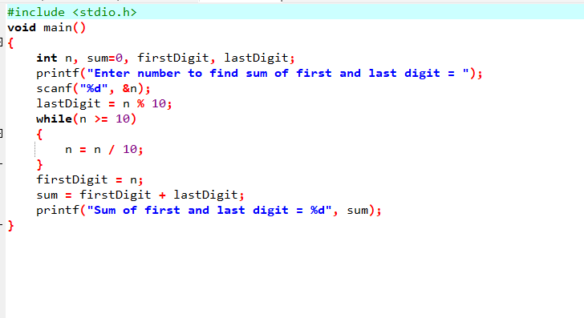



Patterns:

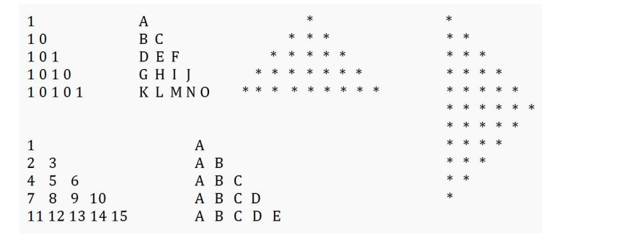

# P1

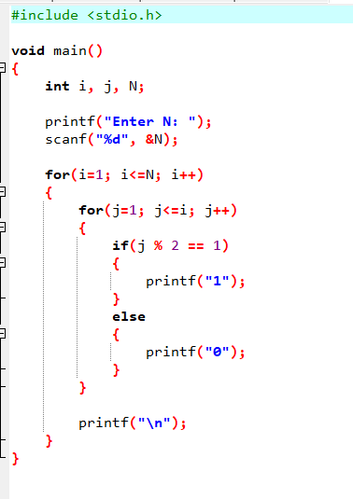

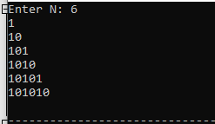

# P2

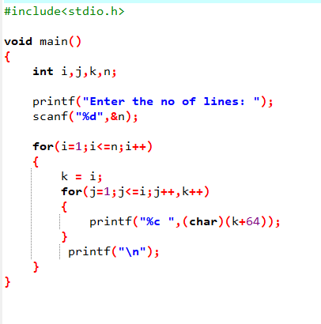

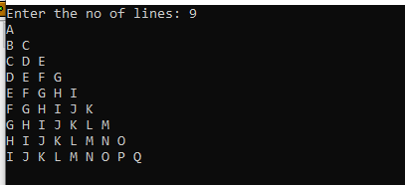

# P3

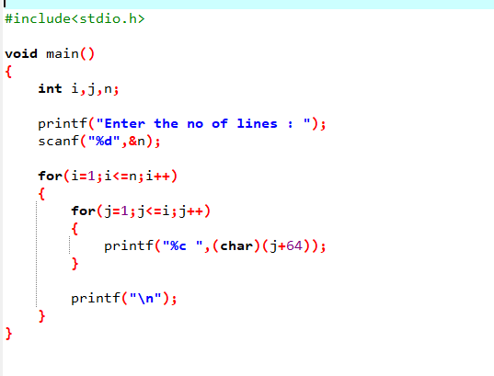

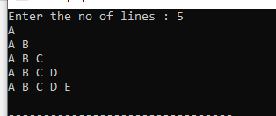

# P4

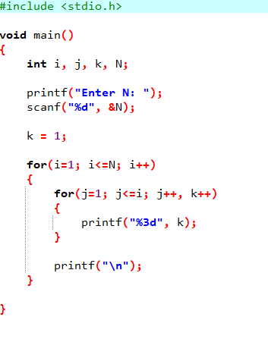

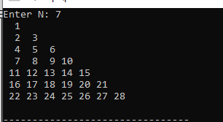

# P5

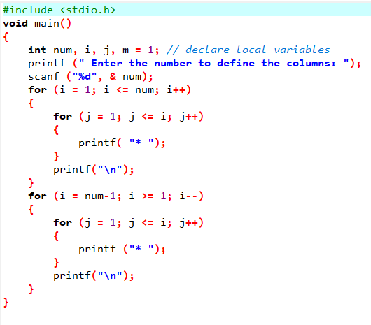

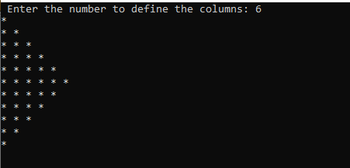

# P6

